CSC 220: Exploring Global Health Crisis Data  
FALL 2022 - Week 9

Research Assistant: Joori Almarzouki

jalmarzouki@uri.edu

horizontal line

# 4 November 2022

Word Cloud

**Creating a word cloud in Tableau:**

A word cloud is a collection, or cluster, of words depicted in different sizes. The bigger and bolder the word appears, the larger the value it represents. 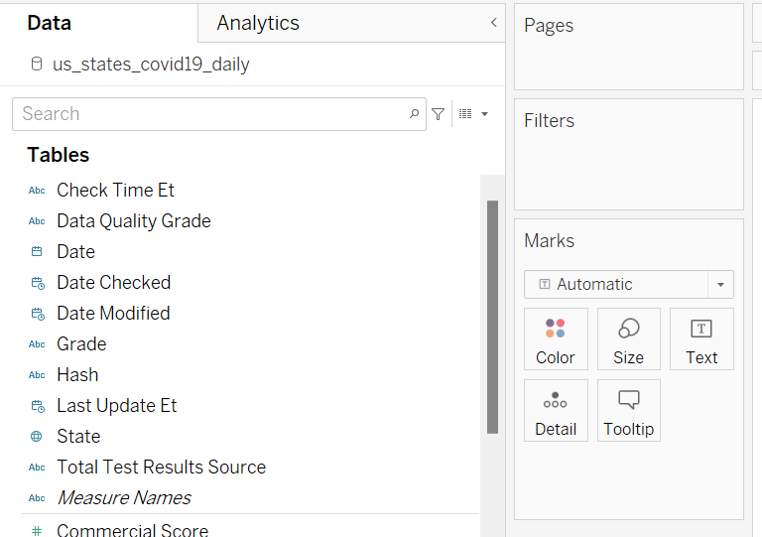

We want the size of each state name to represent the number of Confirmed Deaths.

1. Download the Covid-19 data set [here](https://drive.google.com/file/d/1e8LNlgrmRYifqp5JdKJDI5LCdaM4p75r/view?usp=sharing) & connect it to Tableau.
2. Drag **State** into Text to the Marks Card.



1. Drag **Death Confirmed** to Size.

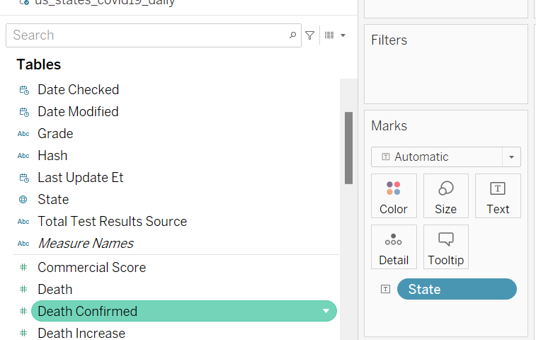

1. Change from Automatic to Text.

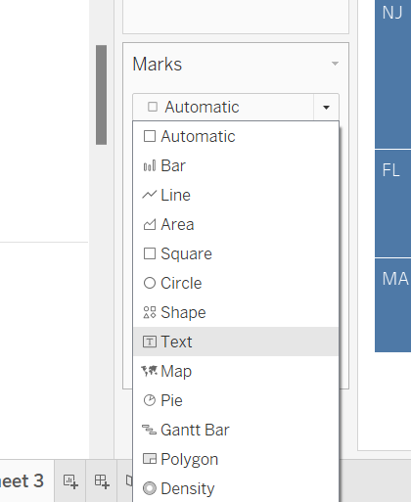

1. Drop **State** into Color.

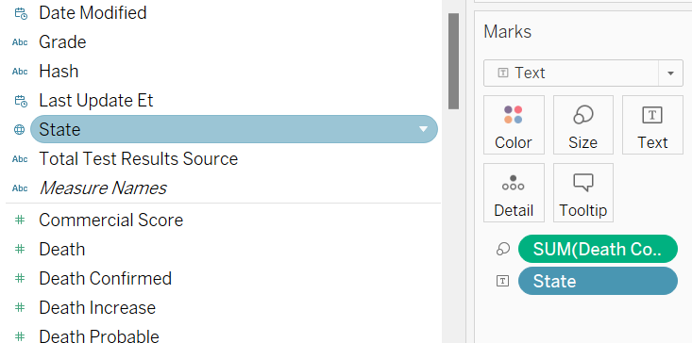

The result should look like this:

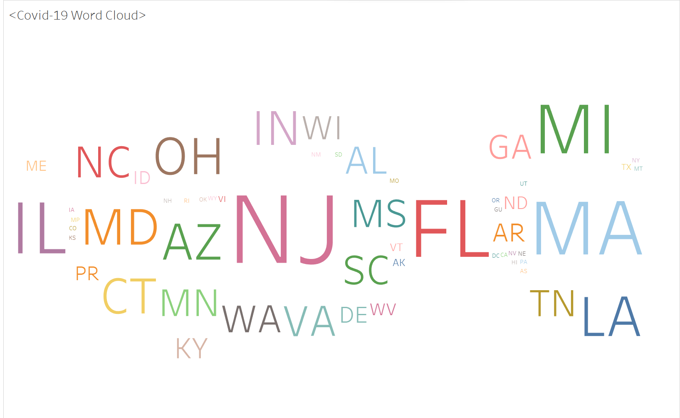

Class Activity:

Create a word cloud where the size of counties' names represents the number of confirmed Ebola deaths in each country.

[Ebola Dataset](https://drive.google.com/file/d/11vJGbCo4zjeHSzr567jUrVtMqnsi6pAI/view?usp=sharing)

Data Cleaning

Data cleaning is the process of fixing or removing incorrect, corrupted, incorrectly formatted, duplicate, or incomplete data within a dataset.

**Tableau Prep Builder:**

Tableau Prep Builder provides a modern approach to data preparation, making it easier and faster to combine, shape, and clean data for analysis within Tableau. By providing a visual and direct path to prep your data, you can get your hands on quality data in just a few clicks.

Here is a short [youtube video](https://www.youtube.com/watch?v=La-UdSJ7fD4&ab_channel=JellymanEducation) showing the data preparation process in Tableau Prep Builder with an example data set.